Nama : Fadzlan Ilham I

NIM : 18090060

Kelas : 5A

**Praktikum 1**

1. Source Code

application/controllers -> kenalan.php

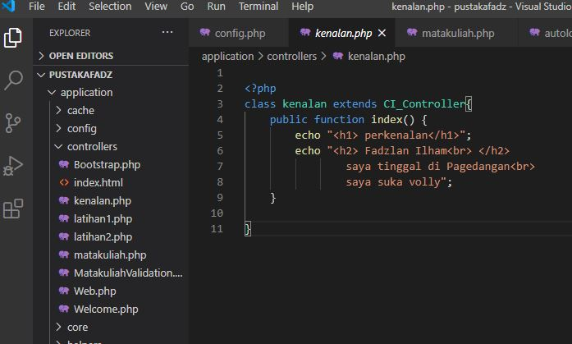

1. URL

[http://localhost/pustakafadz//kenalan](http://localhost/5/pustakachoco/index.php/kenalan)

1. Capture Hasil
2. 